NEWSLETTER
Wood River Soil & Water Conservation District

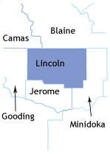
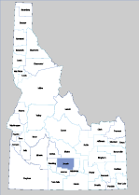
PURPOSE: TO INFORM LANDOWNERS
OF PRACTICES ENHANCING WATER
QUANTITY AND QUALTIY RESOURCE
CONCERNS!
217 West F Street
Shoshone, Idaho 83352

The U. S. Department of Agriculture (USDA) prohibits discrimination in all its programs and activities on the basis of race, color, national origin, gender, religion, age, disability, political beliefs, sexual orientation and marital status. (Not all prohibited bases apply to all programs.) Persons with disabilities who require alternative means for communication of program information (1raille, large print, audiotape, etc.) should contact USDA’s TARGET Center at 202-720-2600 (voice and TDD). To file a complaint of discrimination, write USDA Director, Office of Civil Rights, Room 326 W. Whitten Building, 14th and Independence Ave. SW, Washington, D.C. 20250-9410 or call 202-720-5964 (voice or TDD). USDA is an equal opportunity provider and employer.
WEED MANAGEMENT WORKSHOP COMING SOON
FRIDAY, FEBRUARY 14TH
6 PESTICIDE CREDITS AVAILABLE
PLEASE CALL BARBARA @ 208-886-2258 EXT 100
BY FEBRUARY 3RD FOR LUNCH
WOOD RIVER SOIL &WATER CONSERVATION DISTRICT

DISTRICT BOARD MEMBERS
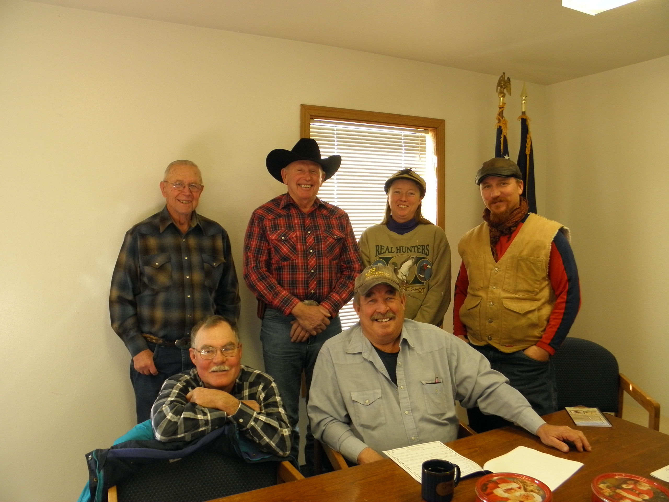

Left sitting: Carl Pendleton-Chairman, Dan Durand- Supervisor - Standing left: Buck Ward - Secretary/ Treasurer, Doug Albright – Vice Chairman, Kerry Thompson, and Dan VanDerMuelen – Supervisors Not pictured Jeff Norman- Supervisor. The District meets the second Wednesday of every month to review business & create ideas for new plans and projects.
2014 TREE ORDER FORMS INSIDE
OR GO TO OUR
WEBSITE:
WWW.WRSWCD.WEEBLY.COM

Calendar of Events
Regular Board Meetings – 2nd Wednesday of the Month
Grazers Gathering – 1st Friday of Every month Community Center
Capital Display
February 2014
Tree Sale forms going out the middle of January
Tree Sale April 25 &26 - 2014
Arbor Day Celebration



DISTRICT PROJECTS:
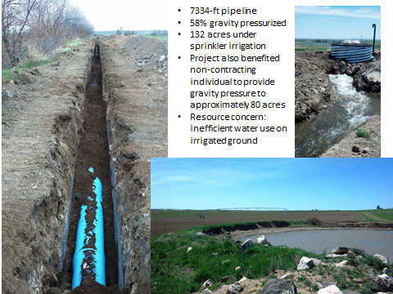
by the WOOD RIVER SOIL AND WATER CONSERVATION DISTRICT
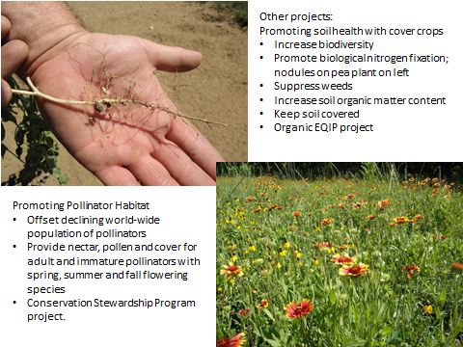
SPEECH WINNER!

Olivia Sutter, Student from Richfield High, was this year’s winner for the Districts annual speech contest.
The theme for this year was “Where Does Your Water Shed”? Olivia prepared a 3 to 5 minute speech on her ideas of the watershed. She then went on to participate at Division IV where she competes with Magic Valley. Olivia finished 3rdand represented the WRSWCD in great fashion.



PRESENTATIONS GIVEN BY THE DISTRICT ON WHAT & WHERE IS YOUR WATERSHED!

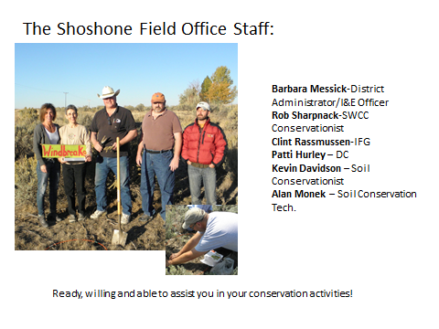

LINCOLN COUNTY
LAND USE / SAGE GROUSE PLAN!
The Wood River SWCD has written a Land Use Plan! It was adopted by the Lincoln County Commissioners December 20,, 2013 and made into the LCLUSGP. The WRSWCD’s intent is to be pro-active as the possibility of the Sage Grouse listing.
Find the plan on our website at www.wrswcd.weebly.com

LEGISLATIVE LUNCHEON
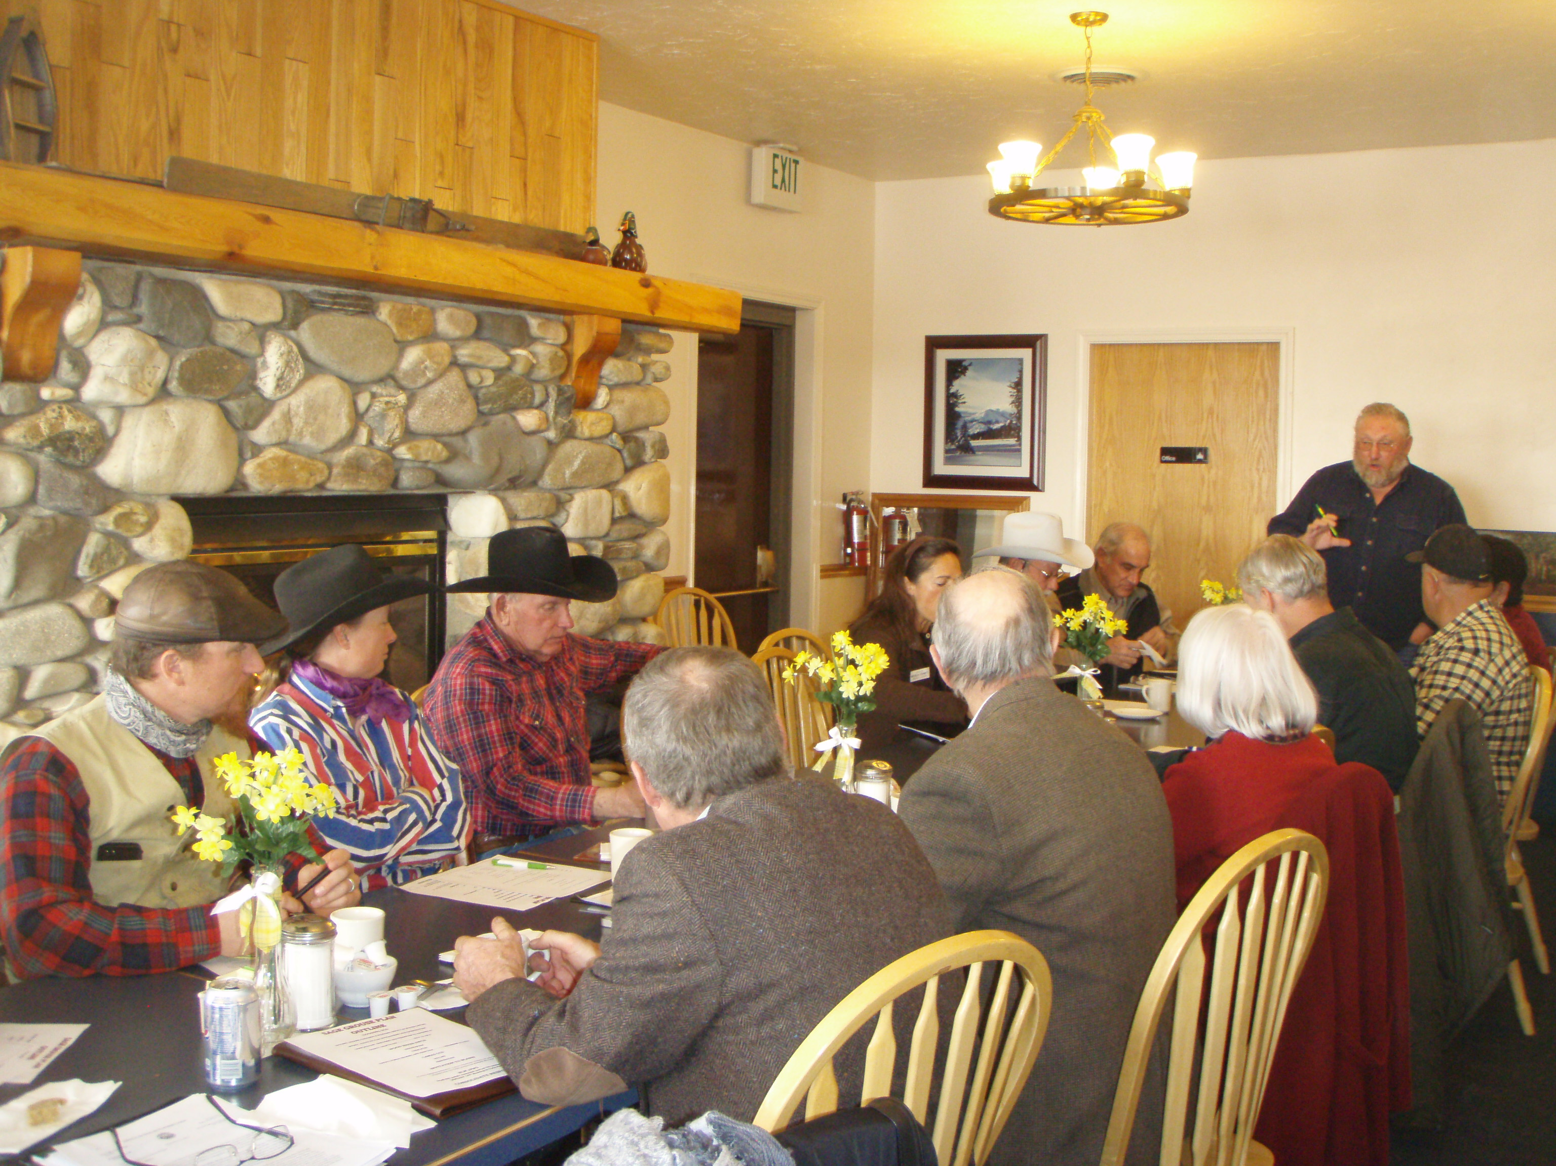
Upper Left Buck Ward, Dan VanDerMuelen, Kerry Thompson and Doug Albright all Wood River Supervisors: Next – Senator; Michelle Stennett, Daniel Butler Gooding SCD & Steve Thompson NRCS Gooding & Camas; standing; Bill Davis Camas SCD, Joe Pavkov Donna Pence, Steve Miller – Representatives and Carl Pendleton WRSWCD.
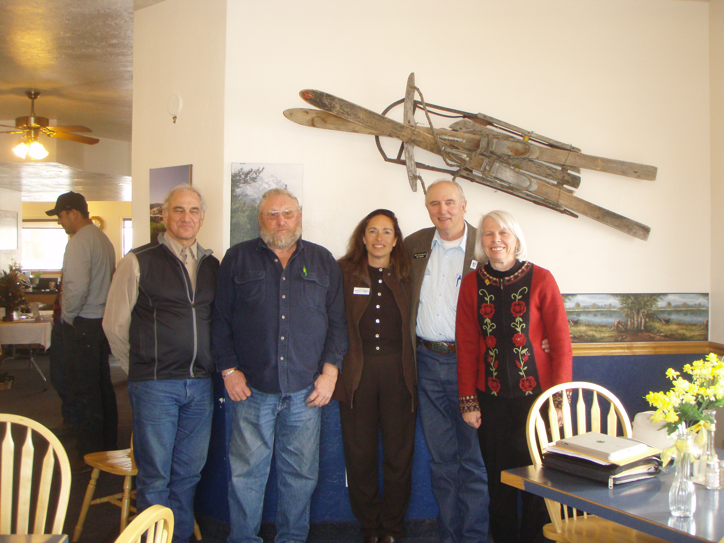

Above Left: Steve Thompson, NRCS; Bill Davis, Camas SCD, Michelle Stennett, Senator; Steve Miller and Donna Pence Representatives:

Each year the local Soil and Water Conservation Districts such as Wood River, Blaine, Camas and Gooding meet with their local legislators. Friday, December 20th all enjoyed the company of Senator, Michelle Stennett, Representative, Steve Miller and Donna Pence before they headed to the Capital. The hot topic of the meeting was the potential listing of the Sage Grouse & what Districts are doing to help in conservation. To date Gooding SCD has written a Sage Grouse Plan and has had it adopted by the County. Wood River SWCD has written a plan and presented to the Lincoln County Commissioners who adopted it December 23, 2013. Camas and Blaine are both on board as they move forward with the planning process for their Counties to adopt. It is then are hope to be a much stronger body as we use these plans as a tool to coordinate. We are dealing with the potential Sage Grouse listing and we all want to be proactive.
We are here for all your needs and services!
5 days a week (Monday – Friday)
(8:00a.m. -4:30 p.m.)

