FROM THE CONSERVATION DISTRICT TO THE LANDOWNER
WINDBREAKS HELP MANY IN LINCOLN COUNTY!
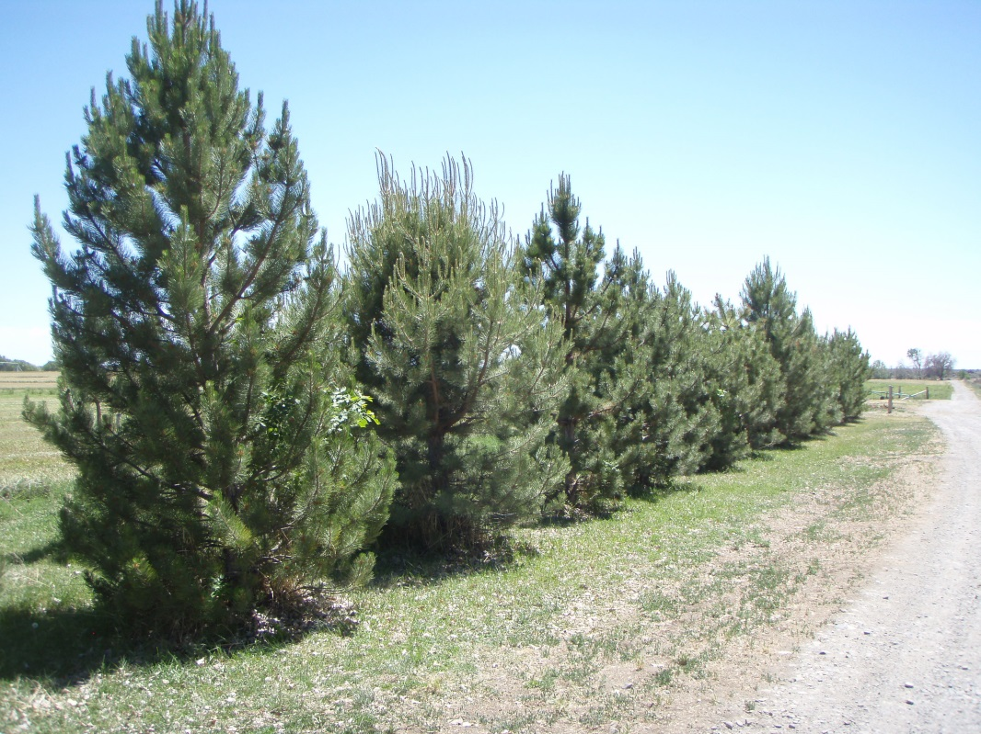
The Wood River Soil and Water Conservation District Board of Supervisor’s would like to express their gratitude to landowners in and around Lincoln County for their contribution to Conservation. If not for Landowner’s who want to make a difference in today’s environment the District would not exist. Protecting the environment and conserving our natural resources today – Is the way of the Future. There are many of you out there and we would like to recognize all of you and what you do!
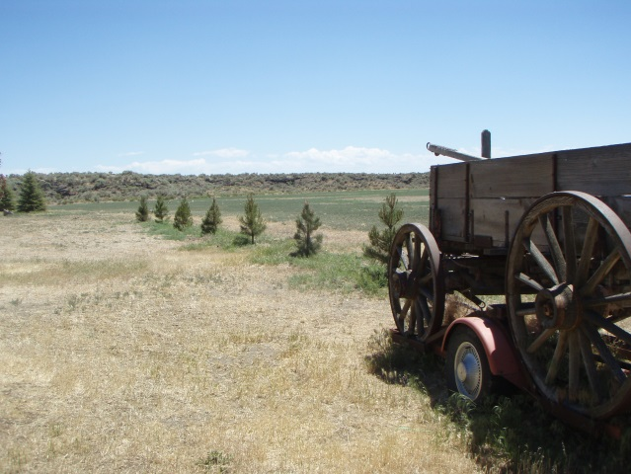
PICTURED LEFT: ARE WINBREAKS, SHELTERBELTS, AND SNOWFENCES OF A LONG TIME FAMILY FARM IN LINCOLN COUNTY. FROM GALLON AUSTRIAN PINE TO MATURE PINES & BLUE SPRUCE.
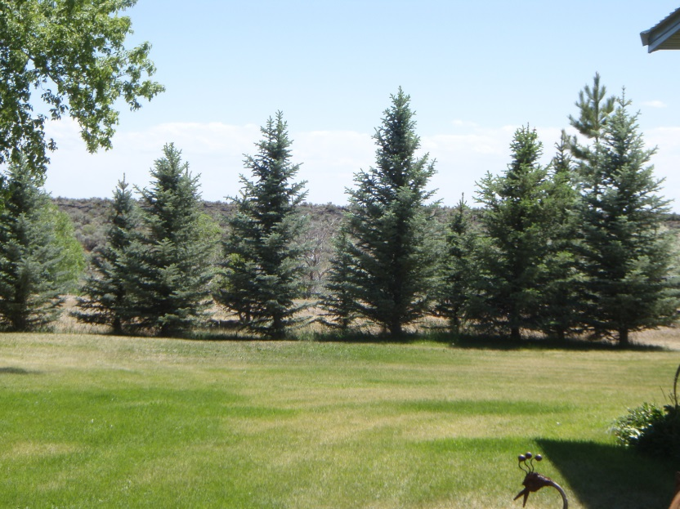

WINDBREAKS ARE NOT OFTEN PLANTED WERE TREES GREW ORIGINALLY. IT TAKES PREPARATION AND A LOT OF HARD WORK AND DEDICATION.
Trees for summer shade may be present on many home sites purchased today and would make the interior living spaces more comfortable. However, in winter, at wind velocities typical of Idaho windbreaks may save 10 to 15 percent of the heating bill. The final effect of vegetation arrangements on total energy needs for heating and cooling will vary with location, weather, and the characteristics of the home. Although up to 75 percent reduction in cooling energy needs can be achieved by providing summer shade, air conditioning is
normally not needed.
FOR MORE INFORMATION ON DESIGNING, PREPARING & PLANTING A WINDBREAK CALL THE WOOD RIVER SWCD @ 208-886-2258 EXT 3 ASK FOR BARB. ORDER FORMS WILL BE COMING SOON!

