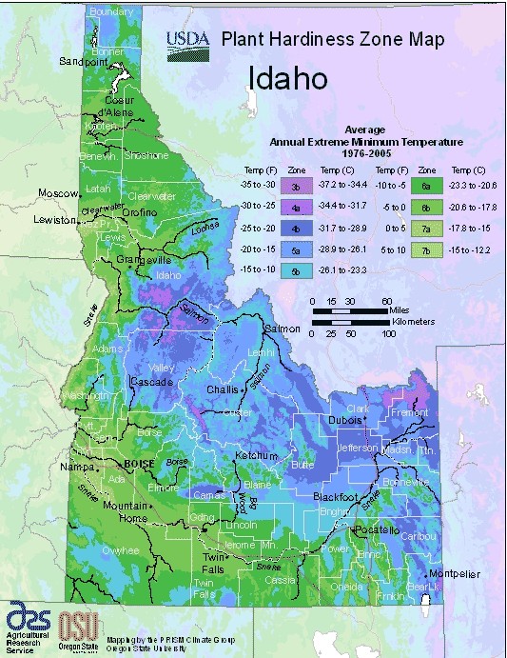
PLANT HARDINESS ZONE MAP

