2020 Conservation Tree Farmer
Lonnie and Charmy LeaVell

The Wood River Soil and Water Conservation District has been in the tree selling business for over 40 years. In that time, we’ve had the privilege of doing business with so many wonderful people. Lonnie and Charmy LeaVell are just one of the couples that we’ve met along the way, who take pride in planting trees and purchased thousands of them from the district. They have built a forest just northwest of Gooding along the Big Wood River where they made it their home and planted trees on their ranch/farm at Magic Reservoir. Lonnie and Charmy have been married for over 33 years and have always loved the outdoors and their environment. They are truly a remarkable couple and here is just a little history on their lives.
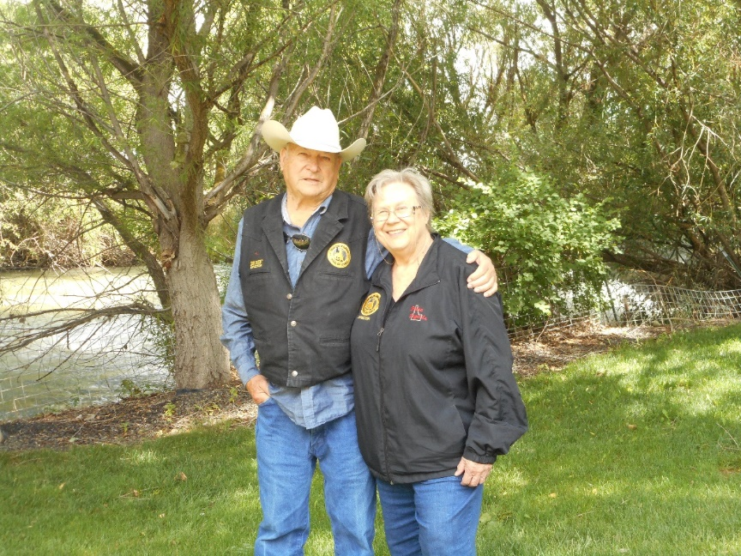
Lonnie was born and raised in Fairfield, Idaho in 1937. This is where he grew up for the first 10 years of his life, before his family moved to California, to go into the dairy business. This adventure only lasted a few years and it wasn’t long before they were back to Idaho.
Lonnie and Charmy in their backyard sanctuary

It was in the late 1970’s that Lonnie really began his tree planting business when he purchased 300 acres above Lucky Peak Nursery in Boise County. His first experience was purchasing hundreds of bare-root pine trees from Lucky Peak Forest Service. He sent a hired man to pick them up and not knowing anything about trees, he sent him with a 2-ton truck to haul them to their Robie Creek property. When he returned, a couple of hours later, he was laughing hysterically, telling Lonnie “I could have picked them up in my car” and he was right. These were bareroot tree/seedlings that were very small and took a lot of care but not much room. This project took them roughly two months to plant, with not a very good success rate. At that same time, Lonnie planted a variety of grasses and wildflower seed. He used a one-ton bale shredder to blow it onto the mountain sides for soil erosion. It was a sight to see!
In 1988, Lonnie returned to Gooding, Idaho to go into a partnership with his father and where he met the love of his life, Charmy. Lonnie and his father purchased two large parcels of range property and a foreclosed 2000-acre farm on Magic Reservoir, all of which had northern slopes and lot of spring water but very few trees. This property was used for sheep back in the day and it wasn’t necessary for property fences. However, when Lonnie and his father came along with his cattle operation, the property had to change, it needed good fences, trees and larger watering areas.
In 1990 with the help of David Sliman, of Sliman Sheep Company, they built 20 miles of new barbwire fences and about 8 new 300-gallon metal water areas with enclosed corrals to pick up sick or crippled animals. It was roughly around that time that Lonnie& Charmy began to purchase approximately 1000 bare root trees a year and began planting. While the District loved selling him trees, we always wondered where he was planting all of them and couldn’t fathom how many acres they had established. He was growing a forest and windbreaks, shelterbelts and snow fences for the love of nature.
In 1993 Lonnie’s father passed away, from a rare and aggressive from of testicular cancer. As a result of his passing they lost some of the ground through questionable circumstances.
It wasn’t until 2 years later that they were able to get back most of the property they
planted trees on.

In 2005 Lonnie & Charmy sold their grazing operation but kept the Gooding feed yard and purchased five neighboring properties, that were native-non-irrigated land. They drilled 20 domestic irrigation wells and kept planting thousands of bare root trees every year.
Phase I was to purchase 40 acres of irrigation well water and 32 acres of Wood River water to be transferred to the feed lot area, that they developed into 30 / 3-5-acre parcels. It has taken approximately 15 years to develop this piece of property into saleable condition, but they have really enjoyed it.
Phase II involved the old livestock sale yard property as well as trying to balance a 3500 head CAFO.
In 2013 and 2014 Lonnie and Charmy formed the non-profits Idaho Rodeo Hall of Fame and Gooding Restoration for Entertainment, Arts and Theater, Inc. (aka GREAT, Inc.) After purchasing the historic Schubert Theater, built in 1920 by the late Governor Frank R. Gooding and whom the city and county are named, they donated it to GREAT, Inc. and are restoring it for the community.
On December 12, 2015 – Lonnie and wife Charmy were both awarded the prestigious Historic Preservation Recognition Award from the National Society of the Daughters of American Revolution for their work to preserve the history of the western way of life through the Idaho Rodeo Hall of Fame and for preservation of the history of the 100-year-old historic Schubert Theater in Gooding, Idaho.

In 2017 Lonnie & Charmy were ready to wrap up the cattle operation and started the removal of the feed lot, corrals and feed bunks. It was always his plan to continue planting trees, but his dad was not always in favor, as he liked white fences. It was always Lonnie’s dream to have trees and green grasses flowing in the wind as property dividers, windbreaks and wildlife habitat. However, this project took considerably more time, but Lonnie believed it was worth it.
Lonnie and Charmy are now retired but continue to be involved in many non- profit organizations such as Idaho Rodeo Hall of Fame, Inc., Gooding Restoration for Entertainment, Arts and Theater, Inc., and Blue Fire Co. and own the Wood
River Estates. In 2009 Lonnie was inducted into the Cowboy Hall of Fame and 2017 Charmy was inducted into the Idaho Rodeo Hall of Fame.
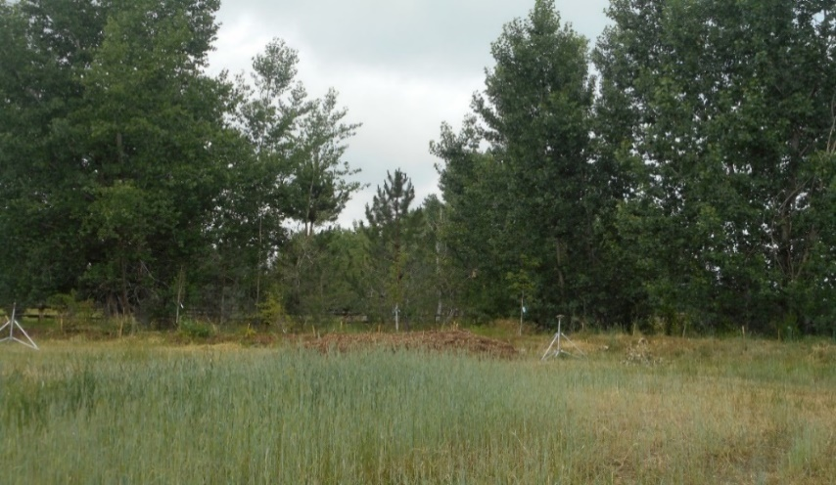
They continue to purchase trees and help the conservation district out in so many ways.
We can’t thank them enough for their business and service to our communities,
environment, and natural resources. (Blue Fire Co. and Restoring the Schubert Theater), they are also active in the Gooding County Fair and Idaho Rodeo Hall of Fame and own the Wood River Estates. They continue to purchase trees and help the conservation district out in so many ways. We can’t thank them enough for their business and service to our Linocln and Gooding
communities, environment and natural resources.

Please join the Wood River Soil and Water Conservation District in their efforts to demonstrate their appreciation in recognizing these two wonderful people Lonnie and Charmy LeaVell as this year Conservation Tree Farmers of the Year!

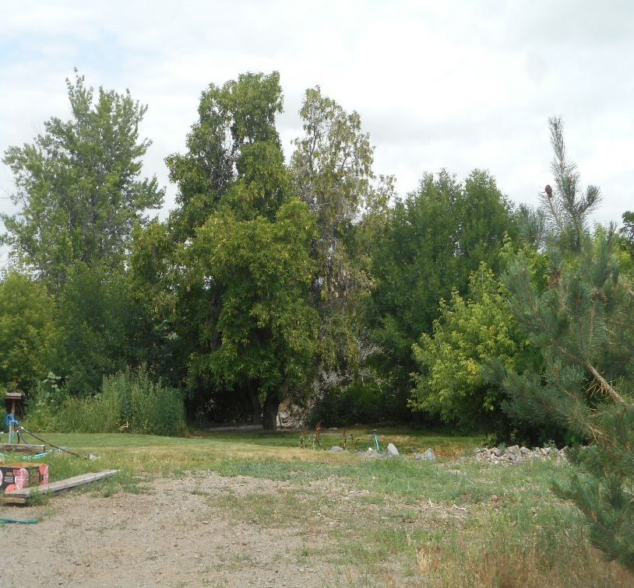
Beautiful piece of
Property on the Big Wood
River north west of Gooding

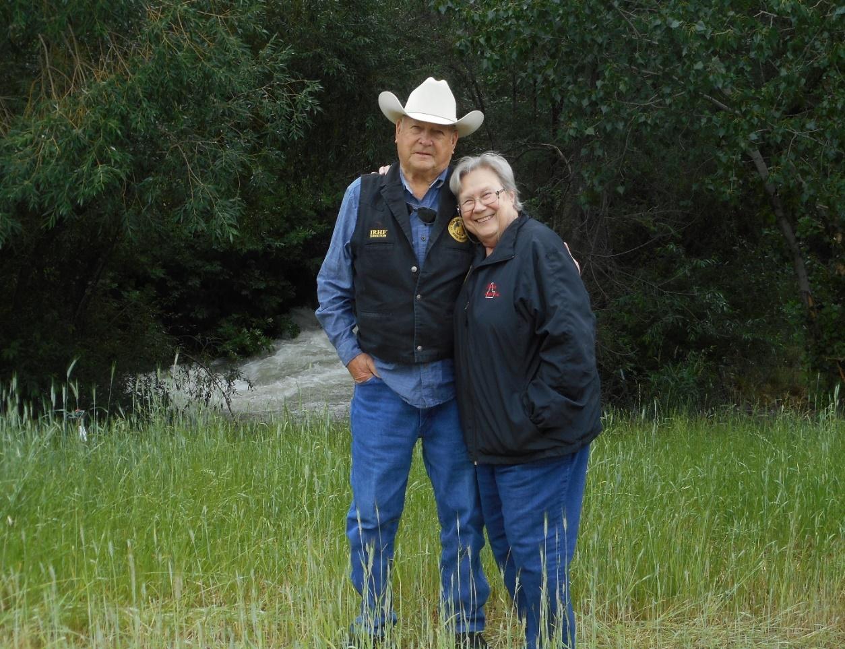
Property that they have planted trees on along the Big Wood River

