950 E ROAD 702-A LATERAL
PIPELINE PROJECT
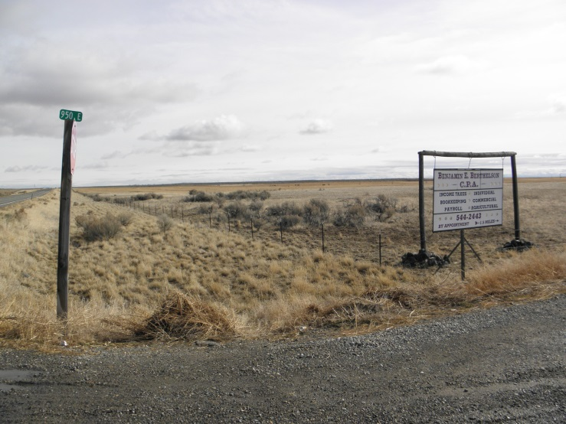

Proposal for Regional Conservation Partnership Program
Improving Water Quantity within the Little Wood River Watershed

Lead Facilitating Partner:

Carl Pendleton – Chairman
The Wood River Soil and Water Conservation District

217 West F Street

Shoshone, Idaho 83352
1-208-886-2258 ext. 101
wrwscd@gmail.com

Partners Associated with Proposal:
- 950 E Road Cooperative Group
- The Wood River Soil and Water Conservation District
- Big Wood Canal Company
- Idaho Department of Water Resources
- Idaho Power

- Applying for the IDAHO STATE funding pool:

GENERAL SUMMARY:

Project Description:

The 702-A Lateral Pipeline Project area lies within the Dietrich Tract of the Big Wood Canal Company and the Wood River Soil and Water Conservation District. The 702- A Project is located approximately 2 ½ miles east of Dietrich, Idaho. The project drainage commences from Dietrich, Idaho to Shoshone @ Township 6S; Range19E; Sections: 8, 16, 17, 19,20,21,22, 27, 28, 29, 30, 32, 34.

The 702-A Lateral Pipeline Project involves six landowners called the (950 Cooperative Group) who are
interested in saving water; making Water Quantity our primary resource of concern. In 2013 these
landowners applied for financial assistance through the Agricultural Water Enhancement Program
(AWEP) to replace their water delivery from lateral 702-A lateral with a Pipeline (trunk line) nearly 3.7
miles and many smaller pipelines @ 5.2 miles for a total pipeline of 8.9 in length.
It is the landowner’s intent to have the Big Wood Canal Company take measurements for monitoring
annually.

The secondary resource of concern is Energy and the 702-A Lateral Pipeline Project delivery system
would save 100% of the pumping cost due to gravity flow. This pipeline will also supply
gravity pressure to the landowners’ existing sprinkler systems thus reducing their power costs. Gravity
pressure is estimated to range from 40 psi to 75 psi.

The Big Wood Canal Company prepared a study in 2009 with the University of Idaho and local

landowners stating the benefits of water savings within the 702- A lateral project area. The

study shows a significant amount of water would be saved if the lateral was piped. The study indicates

a savings of 30 cfs or 60 acre feet per day while 6 days of water would be gained. It also points out that

$75,000.00 per day of revenue could be generated with this water savings; Therefore the 6 days that

would be gained would produce $450,000.00 for Magic water users. Ultimately by piping 3400 acres

we would increase the revenue potential on the Big Wood Canal System to the Magic Reservoir Users

totaling approximately 36,500.00 acres.

Hydrological unit code / HUC: 17040221
Little Wood River watershed is a mix use of both private and BLM public ground. The project consists
of roughly 3400 acres on private land and would be a great benefit to “Water Quantity” our primary
resource of concern.

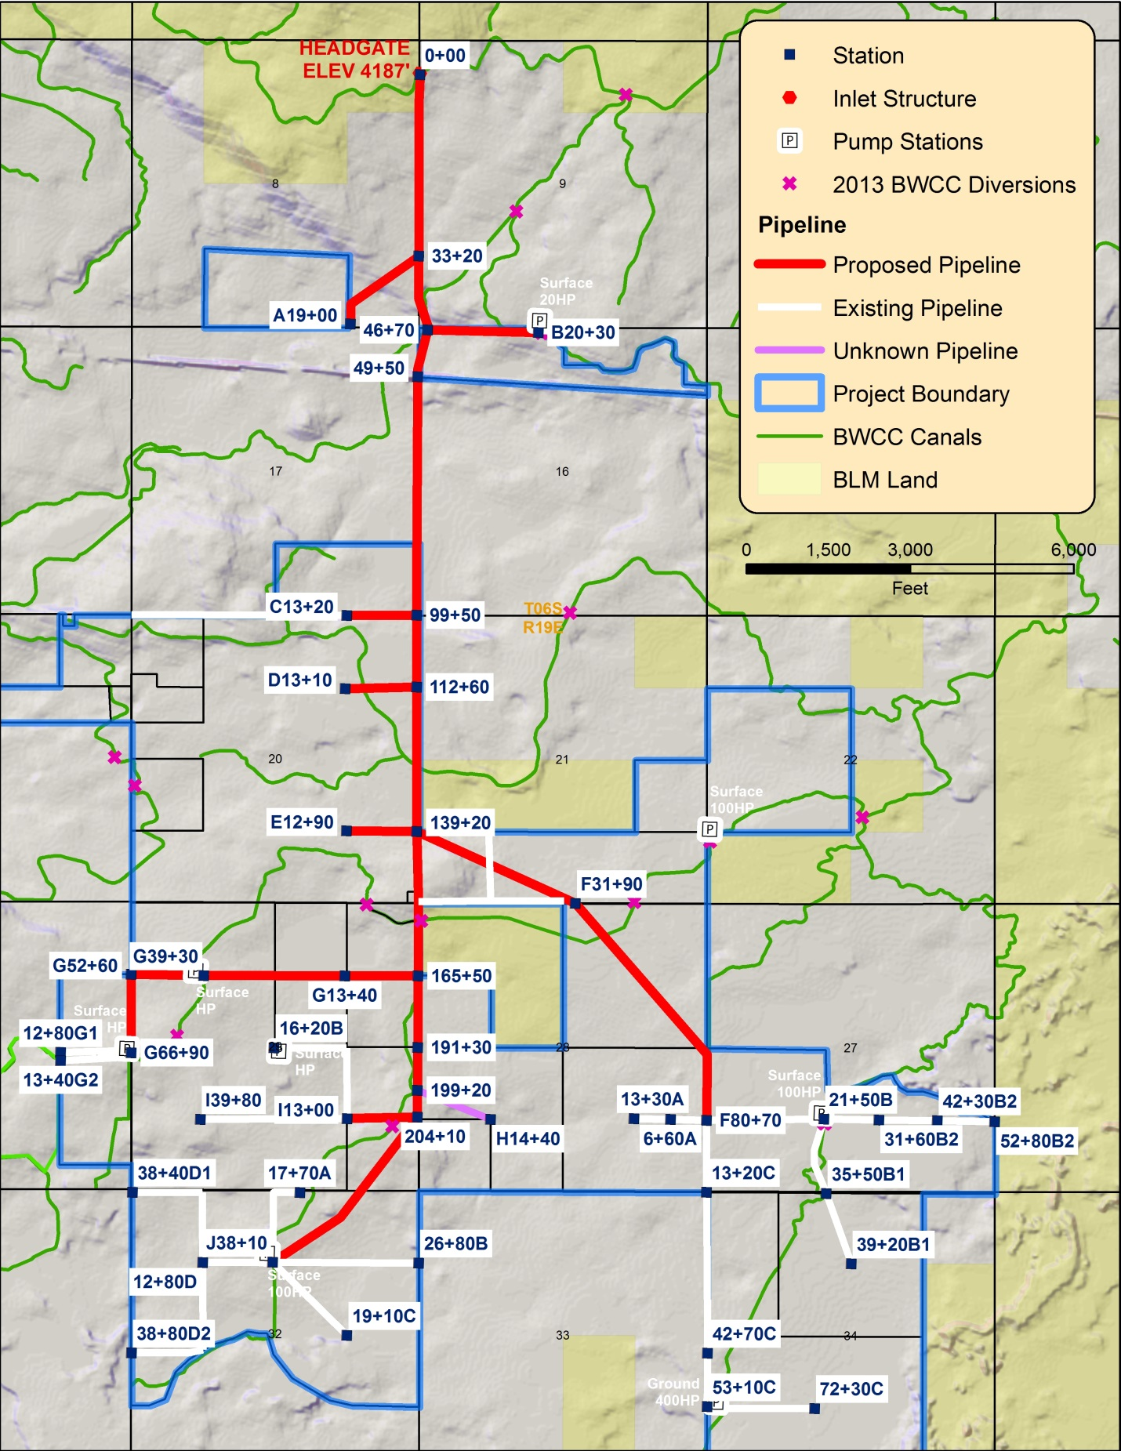
- Dietrich Pipeline Project

All numbers presented in this report are preliminary. Hydraulics and pipe sizing are a work in progress.

950 Road - 702 Lateral Dietrich Pipeline Project
Landowner | Acreage | Surface Water; gpm | Surface Shares | % shares
Hubert Shaw | 1587.46 | 3903.75 | 694 | 38.34%
Astle Farms | 888.39 | 2998.125 | 533 | 29.45%
Stan Ward | 610.18 | 1760.625 | 313 | 17.29%
Kenneth Anhder | 136 | 776.25 | 138 | 7.62%
Gene Shaw | 80 | 562.5 | 100 | 5.52%
Jess Southwick | 32 | 180 | 32 | 1.77%
Totals: | 3334.03 | 10181.25 | 1810
Shares are calculated at 0.625”/share.

A new head gate is planned off the Dietrich Main Canal with self-cleaning screens similar to that installed for the 750 E Road pipeline.
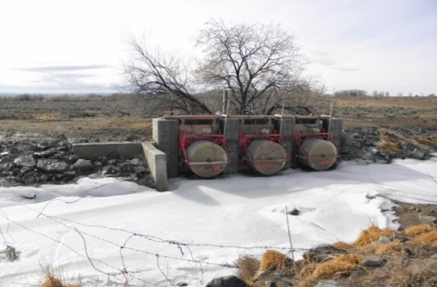

Head Gate for the 750 Road Pipeline off of the Dietrich Main Canal.

The 702-A Pipeline will be installed according to ID-NRCS Construction Specifications 430-A for
underground plastic pipe.

All easements through neighboring properties, across the roads/highways and under the railroad are the
responsibility of the six landowners.

Estimated Time of Project:
The proposed 702-A Lateral Pipeline Project will be completed in 1 year.
December 2015 through December 2016.

Dates | Activity | Responsible  Entity | Date to be completed
FY-2015 | Technical Assistance to NRCS  Planning &  Engineering  Assist in Planning  Other funding Source | WRSWCD  NRCS  Big Wood Canal Co.  IDWR  Idaho Power | 2016  2016  2016  2016

- No monitoring needed! Once installed, objectives of water savings and energy savings are met.

Request for RCPP Budget funding:

Landowner | Acres | Landowner s Cost Trunk line | To Farm Delivery | Total  Cost
Hubert Shaw | 1587.46 | $ 399,457.06 | $ 36,042.30 | $ 435,499.36
Astle Farms | 888.39 | $ 306,833.86 | $ 105,312.40 | $ 412,179.26
Stan Ward | 610.18 | $ 180,141.17 | $ 37,570.90 | $ 217,712.07
Kenneth Anhder | 136 | $ 79,391.30 | $ 7,065.60 | $ 86,456.69
Gene Shaw | 80 | $ 57,511.81 | $ 11,833.00 | $ 69,344.81
Jess Southwick | 32 | $ 18,441.28 | $ 4,323.90 | $ 22,765.18
Big Wood Canal Co. | 3334.03 |  |  | $ 130,000.00
Total Project Cost |  | $ 1,041,880.70 | $ 207,069.00 | $ 1,248,949.70
Less Landowner  Contribtuion |  |  |  | $ 624,474.85
Less Idaho Power  Contribution |  |  |  | $ 130,000.00
Less Big Wood Contribution |  |  |  | $ 70,000.00
Total RCPP Funds Requested | 3334.03 | $ 390,949.35 | $ 103,534.50 | $ 424,474.85
NRCS Tech Support | 6 landowners x 100hr. per x $30.00 |  |  | $ 180,000.00
The Big Wood Canal Company and Idaho Power have both committed to the 950 E 702-A
Pipeline project, while NRCS and Wood River SWCD are asking for TA time as well.

PROJECT SUMMARY

Objectives of the 702-A Lateral Pipeline Project:

The proposed project will produce 3.7 miles of trunk line & 5.2 miles of smaller pipeline on the 702-A
lateral. This would pressurize many of the sprinkler irrigation systems already in place thereby
eliminating or minimizing return flows from the present flood irrigation systems to the river.

Specific NRCS approved conservation practices that are anticipated to be installed to address
Water Quantity includes:
430 Pipeline Irrigation Water Pipeline
587 Water Structure

In addition to the NRCS resources requested, the partner proposes to provide services to producers to help plan and monitor efforts to conserve irrigation water and address energy issues within the project area.

Specifically, the Big Wood Canal Company Irrigation District will provide irrigation system design services to producers participating in the project area. The Wood River Soil and Water Conservation District (SWCD) will be the administrator and information - educational partner.

By the end of the project, the partnership hopes to provide a 47% percent decrease in overall use of groundwater resources and anticipates helping roughly 20% of participating producers to meet the state water quality permit requirements.
- Increasing efficiency of water delivery will help avoid water restrictions and water calls in the future.

The project will also produce secondary impacts to the watershed.
- Efficient delivery and utilization of water resources will increase available water supply for all uses.
- More efficient electric use.

Description of Activities:

- Conservation Practice’s - This proposed project will have an approximate water savings of
47 % or 30cfs roughly 60 acre ft. per day to service multiple landowners.

- Conservation Activity Plans – This project is based on common sense and sound scientific principles. Elimination of irrigation return flows using pressurized irrigation system management is a proven BMP.
Monitoring will be conducted to ensure that it operates in an efficient manner.

- Enhancements - Public Awareness – This project will demonstrate the use of Water Quantity savings by a gravity pipeline that would maximize the water available for the best use. The outlying areas would also benefit from water quantity in the Little Wood River in water and energy savings.

- Financial Forces & Incentives – This project combines the efforts of two different governmental organizations and the private sector. The landowners stand to gain substantial benefits from this arrangement. The public in general will also benefit.

- No adjustment of terms or alternative funding needed to achieve these goals

Total NRCS RCPP Program Funds Requested: $ 424,474.85

